SIMATS ENGINEERING
ASSESSMENT TOOL 1

COURSE NAME: INTERNET PROGRAMMING
COURSE CODE: CSA43

COURSE OUTCOME COVERED

CO 3: Implement dynamic web applications by utilizing DOM-based client-side scripting and employing Java Servlets for server-side request processing and response handling. (L3)

Assessment Tool : Scenario-Based Assessment

Weightage: 40%
Dr.V.Parthipan

QUESTIONS: Total Marks: 30

Question 1: Online Student Registration using Servlets
Scenario: A college wants an online student registration system where students submit details through a web form and the data is processed by a Java Servlet.

Architecture of a Servlet-Based Application
A servlet application follows a request-response, multi-tier model. The browser (client) sends an HTTP request to a web server / servlet container (such as Apache Tomcat). The container maps the URL to a servlet using web.xml or the @WebServlet annotation, creates request and response objects, and calls the servlet. The servlet processes the data (optionally using a database) and returns a response, usually HTML.

Component | Role
Client (Browser) | Displays the HTML registration form and sends the HTTP request (GET/POST).
Web Server / Servlet Container | Receives requests, manages servlet life cycle, threads, sessions and security (e.g. Tomcat).
Servlet (Controller) | Java class extending HttpServlet. Reads parameters, applies logic, generates the response.
Deployment Descriptor | web.xml or @WebServlet annotation: maps URL patterns to servlet classes.
Database / Model (optional) | Stores student records, accessed from the servlet through JDBC.

Browser --HTTP request--> Web Server --> Servlet Container --> Servlet (init/service/destroy)
^ |
| v
+<-------------HTTP response (HTML)<----------------------- Database (JDBC)
Request flow: (1) The student fills in the form and submits. (2) The container receives the request and finds the matching servlet. (3) If it is not yet loaded, the container loads it and calls init(). (4) A new thread calls service(), which dispatches to doGet() or doPost(). (5) The servlet writes the response through HttpServletResponse. (6) The container sends it to the browser.

Implementation
register.html (the registration form):
<!DOCTYPE html>
<html>
<head><title>Student Registration</title></head>
<body>
<h2>Student Registration Form</h2>
<form action="RegisterServlet" method="post">
Name: <input type="text" name="name" required><br><br> Reg No: <input type="text" name="regno" required><br><br> Email: <input type="email" name="email" required><br><br> Department: <input type="text" name="dept" required><br><br>
Password: <input type="password" name="password" required><br><br>
<input type="submit" value="Register (POST)">
</form>
<hr>
<h3>Search student (GET)</h3>
<form action="RegisterServlet" method="get"> Reg No: <input type="text" name="regno">
<input type="submit" value="Search">
</form>
</body>
</html>

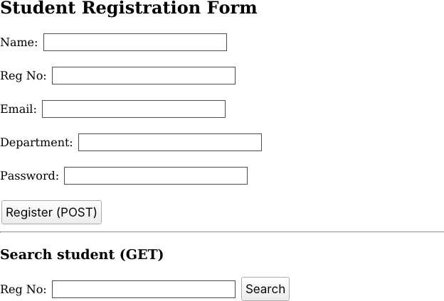
Screenshot 1: register.html rendered in a browser (POST registration form and GET search form).

RegisterServlet.java (handles both GET and POST):
import java.io.*; import javax.servlet.*;
import javax.servlet.annotation.WebServlet; import javax.servlet.http.*;

@WebServlet("/RegisterServlet")
public class RegisterServlet extends HttpServlet {

@Override
public void init() throws ServletException {
// Called once: load config, create DB connection pool, etc. System.out.println("RegisterServlet initialized");
}

// GET: data arrives in the URL query string (visible, bookmarkable, for read/search) @Override
protected void doGet(HttpServletRequest req, HttpServletResponse res) throws ServletException, IOException {
res.setContentType("text/html"); PrintWriter out = res.getWriter();
String regno = req.getParameter("regno"); out.println("<html><body>"); out.println("<h3>GET request received</h3>");
out.println("<p>Searching for Reg No: " + escape(regno) + "</p>"); out.println("</body></html>");
}

// POST: data arrives in the request body (not shown in URL, used for registration) @Override
protected void doPost(HttpServletRequest req, HttpServletResponse res) throws ServletException, IOException {
res.setContentType("text/html"); PrintWriter out = res.getWriter();

String name = req.getParameter("name"); String regno = req.getParameter("regno"); String email = req.getParameter("email"); String dept = req.getParameter("dept");

if (name == null || name.trim().isEmpty() || regno == null || regno.trim().isEmpty()) { res.setStatus(HttpServletResponse.SC_BAD_REQUEST);
out.println("<h3>Error: Name and Reg No are required.</h3>"); return;
}
// (A real system would hash the password and save the record via JDBC here.) out.println("<html><body>");
out.println("<h2>Registration Successful</h2>");

out.println("<p>Name: " + escape(name) + "</p>"); out.println("<p>Reg No: " + escape(regno) + "</p>"); out.println("<p>Email: " + escape(email) + "</p>"); out.println("<p>Department: " + escape(dept) + "</p>"); out.println("</body></html>");
}

// Prevent cross-site scripting by escaping user input before printing it private String escape(String s) {
if (s == null) return "";
return s.replace("&", "&amp;").replace("<", "&lt;").replace(">", "&gt;");
}

@Override
public void destroy() {
// Called once before unloading: release resources System.out.println("RegisterServlet destroyed");
}
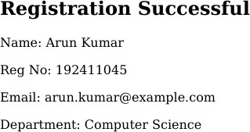

}

Screenshot 2: HTML page produced by doPost() for a sample registration (left) and by doGet() for a sample search (right).
Sample values are used for illustration.
If web.xml is used instead of the annotation, add a <servlet> entry with
<servlet-class>RegisterServlet</servlet-class> and a <servlet-mapping> with
<url-pattern>/RegisterServlet</url-pattern>.

Servlet Life Cycle

Phase | Method | Description
Loading and instantiation | Constructor | The container loads the class and creates one instance (on first request or at startup).
Initialization | init(ServletConfig) | Called once after instantiation. Used for one-time setup such as reading init parameters or opening resources.
Request handling | service(req, res) | Called for every request, each in its own thread. HttpServlet.service() reads the HTTP method and calls doGet(), doPost(), etc.
Destruction | destroy() | Called once when the servlet is removed or the server shuts down. Used to close connections and free resources.
Load class -> new instance -> init() [once] -> service() -> doGet()/doPost() [many times] -> destroy() [once]
Only one servlet instance exists per declaration, and many threads share it. Instance variables should therefore not hold per-request data, as this would cause thread-safety problems.

GET vs POST and Which Is Appropriate for Sensitive Data

Feature | GET | POST
Data location | Appended to the URL as a query string | Sent in the HTTP request body
Visibility | Visible in the address bar, history, bookmarks and server logs | Not shown in the URL

Feature | GET | POST
Size limit | Limited (URL length) | Practically unlimited
Idempotent / cacheable | Yes, can be cached and bookmarked | No, not cached by default
Typical use | Searching, reading data | Registration, login, updates, file uploads
Servlet method | doGet() | doPost()
Justification: POST is more appropriate for sensitive data such as passwords, personal details and Aadhaar or phone numbers. With GET these values appear in the URL, where they are stored in browser history, proxy and server logs and the HTTP Referer header, and can be seen by shoulder-surfing. POST keeps them out of the URL, and it also suits operations that change server state, such as registration. Note that POST by itself does not encrypt data. HTTPS must also be used so that the body is protected in transit.

Question 2: Session Management using HttpSession and Cookies
Scenario: A website requires users to log in and maintain their session across multiple pages after authentication.

How Session Tracking Works
HTTP is a stateless protocol: each request is independent, and the server does not remember who sent the previous one. Session tracking lets the server link a series of requests from the same user. The common techniques are:
    - Cookies: small name-value pairs stored by the browser and sent back with every request to the same site.
    - HttpSession: a server-side object that stores user data. The container generates a unique session ID (JSESSIONID), usually delivered to the browser as a cookie.
    - URL rewriting: the session ID is appended to every URL (e.g. page;jsessionid=ABC123), used when cookies are disabled.
    - Hidden form fields: the ID is carried in hidden input fields of forms.
Working: (1) After a successful login, the servlet calls request.getSession(). The container creates a session object with a unique ID. (2) The ID is sent to the browser in a Set-Cookie: JSESSIONID=... header. (3) On each later request the browser sends the cookie back. (4) The container finds the matching session object and returns it from getSession(), so the servlet can read the stored attributes. (5) The session ends on logout (invalidate()) or after a timeout of inactivity.
Login --> Server creates HttpSession (ID = A1B2) --> Set-Cookie: JSESSIONID=A1B2
Next page --> Browser sends Cookie: JSESSIONID=A1B2 --> Server finds session A1B2 --> user recognised

Design and Implementation
The design uses four servlets: LoginServlet (authenticates, creates the session and an optional 'remember me' cookie), DashboardServlet and other protected pages (check the session), and LogoutServlet (invalidates the session). A filter can protect many pages in one place.

login.html:
<form action="LoginServlet" method="post">
Username: <input type="text" name="username" required><br> Password: <input type="password" name="password" required><br>
<input type="checkbox" name="remember" value="yes"> Remember my username<br>
<input type="submit" value="Login">
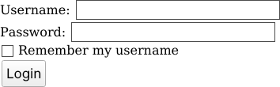
</form>

Screenshot 3: login.html rendered in a browser.

LoginServlet.java:
import java.io.*; import javax.servlet.*;
import javax.servlet.annotation.WebServlet; import javax.servlet.http.*;

@WebServlet("/LoginServlet")
public class LoginServlet extends HttpServlet {
protected void doPost(HttpServletRequest req, HttpServletResponse res) throws ServletException, IOException {
String user = req.getParameter("username"); String pass = req.getParameter("password");

// Demo check. A real system queries the DB and compares a hashed password. if ("admin".equals(user) && "secret123".equals(pass)) {

// Prevent session fixation: discard any old session, then create a new one HttpSession old = req.getSession(false);
if (old != null) old.invalidate(); HttpSession session = req.getSession(true);

session.setAttribute("user", user); session.setAttribute("loginTime", new java.util.Date().toString());
session.setMaxInactiveInterval(15 * 60); // 15 minutes timeout

// Cookie to remember the username (not the password!) if ("yes".equals(req.getParameter("remember"))) {
Cookie c = new Cookie("rememberedUser", user); c.setMaxAge(7 * 24 * 60 * 60); // 7 days
c.setHttpOnly(true); // not readable by JavaScript
c.setSecure(true); // sent only over HTTPS c.setPath("/");
res.addCookie(c);
}
res.sendRedirect("DashboardServlet");
} else {
res.setContentType("text/html");
res.getWriter().println("<p>Invalid credentials. <a href='login.html'>Try again</a></p>");
}
}
}
DashboardServlet.java (a protected page, reusable for every page after login):
@WebServlet("/DashboardServlet")
public class DashboardServlet extends HttpServlet {
protected void doGet(HttpServletRequest req, HttpServletResponse res) throws ServletException, IOException {

HttpSession session = req.getSession(false); // false: do NOT create a new session if (session == null || session.getAttribute("user") == null) {
res.sendRedirect("login.html"); // not logged in return;
}
res.setContentType("text/html"); PrintWriter out = res.getWriter();
out.println("<h2>Welcome, " + session.getAttribute("user") + "</h2>"); out.println("<p>Logged in at: " + session.getAttribute("loginTime") + "</p>"); out.println("<p>Session ID: " + session.getId() + "</p>");
out.println("<a href='LogoutServlet'>Logout</a>");
}
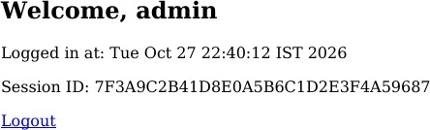
}

Screenshot 4: protected page produced by DashboardServlet after a successful login (sample user, time and session ID shown for illustration).

LogoutServlet.java:
@WebServlet("/LogoutServlet")
public class LogoutServlet extends HttpServlet {
protected void doGet(HttpServletRequest req, HttpServletResponse res) throws ServletException, IOException {
HttpSession session = req.getSession(false);
if (session != null) session.invalidate(); // destroys server-side session data

Cookie c = new Cookie("rememberedUser", ""); // delete the remember-me cookie c.setMaxAge(0);
c.setPath("/"); res.addCookie(c); res.sendRedirect("login.html");

}
}
Optional: AuthFilter to protect all pages without repeating the check:
@WebFilter("/secure/*")
public class AuthFilter implements Filter {
public void doFilter(ServletRequest rq, ServletResponse rs, FilterChain chain) throws IOException, ServletException {
HttpServletRequest req = (HttpServletRequest) rq; HttpSession s = req.getSession(false);
if (s != null && s.getAttribute("user") != null) chain.doFilter(rq, rs);
else ((HttpServletResponse) rs).sendRedirect(req.getContextPath() + "/login.html");
}
}
Security points in the design: the session is recreated at login to prevent session fixation; a timeout limits exposure; cookies carry HttpOnly and Secure flags; sensitive data such as passwords is never stored in cookies; logout invalidates the session; HTTPS is used throughout.

Comparison: Session-Based Tracking vs Cookies

Aspect | HttpSession (session-based) | Cookies
Storage location | On the server; only the session ID goes to the client | On the client browser
Data type | Any Java object (setAttribute) | Only small text strings (name-value)
Size limit | Limited only by server memory | About 4 KB per cookie, around 20 per domain
Security | More secure: data is not exposed to the user | Less secure: can be viewed or edited by the user and stolen via XSS or sniffing
Lifetime | Until timeout (default about 30 min) or invalidate() | Until expiry set by setMaxAge(), can persist after the browser closes
Server load | Uses server memory for every active user | No server memory used
Scalability | Needs sticky sessions or shared session store in clusters | Scales easily, as the server stays stateless
Dependency | Normally relies on a cookie (JSESSIONID); falls back to URL rewriting | Fails if the user disables cookies
Best for | Login state, shopping cart, user profile | Preferences, language, 'remember me', analytics
Conclusion: Cookies and sessions work together rather than compete. The session holds the sensitive state on the server, while a cookie carries only the session ID (and non-sensitive preferences) to identify the user on each request. For authentication, HttpSession is the correct choice.

Question 3: JDBC-Based Product Management for an E-Commerce Platform
Scenario: An e-commerce platform needs to store and retrieve product details from a database using a Java-based web application.

JDBC Architecture
JDBC (Java Database Connectivity) is a standard Java API (packages java.sql and javax.sql) that lets Java programs talk to relational databases in a database-independent way. Its two-layer architecture is:
    - JDBC API layer: the interfaces the application uses: DriverManager, Connection, Statement, PreparedStatement, ResultSet, SQLException.
    - JDBC Driver layer: a vendor-specific driver (e.g. MySQL Connector/J) that implements those interfaces and translates calls into the database's native protocol.
Java Application (Servlet/JSP)
|
JDBC API (DriverManager, Connection, Statement, ResultSet)
|
JDBC Driver Manager
|
JDBC Driver (MySQL / Oracle / PostgreSQL ...)
|
Database (products table)

Component | Purpose
DriverManager | Loads drivers and creates connections from a URL, user and password.
Connection | Represents a session with the database; creates statements and controls transactions.
Statement / PreparedStatement | Executes SQL. PreparedStatement is precompiled, uses ? placeholders and prevents SQL injection.
ResultSet | Table of rows returned by a SELECT; read with next() and getXxx().
SQLException | Reports database errors (message, SQLState, error code).
Driver types: Type 1 (JDBC-ODBC bridge, obsolete), Type 2 (native API), Type 3 (network protocol) and Type 4 (pure Java, thin driver). Type 4 is the most widely used today.

Steps for Database Connectivity
    - Step 1 - Import packages: import java.sql.*;
    - Step 2 - Load and register the driver: Class.forName("com.mysql.cj.jdbc.Driver") (optional with JDBC 4+, which auto-loads drivers found on the classpath).
    - Step 3 - Establish the connection: DriverManager.getConnection(url, user, password).
    - Step 4 - Create a statement: PreparedStatement ps = con.prepareStatement(sql).
    - Step 5 - Execute the query: executeUpdate() for INSERT/UPDATE/DELETE, executeQuery() for SELECT.
    - Step 6 - Process the results: iterate over the ResultSet with rs.next().
    - Step 7 - Close resources: close ResultSet, Statement and Connection, ideally with try-with-resources.

Database Design
CREATE DATABASE ecommerce;
USE ecommerce;

CREATE TABLE products (
product_id INT PRIMARY KEY AUTO_INCREMENT,

name VARCHAR(100) NOT NULL,
category VARCHAR(50),
price DECIMAL(10,2) NOT NULL CHECK (price >= 0),
stock INT DEFAULT 0
);

Implementation with Exception Handling
DBUtil.java (central connection helper):
import java.sql.*;

public class DBUtil {
private static final String URL = "jdbc:mysql://localhost:3306/ecommerce"; private static final String USER = "root";
private static final String PASS = "password"; // load from config/env in real projects

static {
try {
Class.forName("com.mysql.cj.jdbc.Driver");
} catch (ClassNotFoundException e) {
throw new ExceptionInInitializerError("MySQL driver not found: " + e.getMessage());
}
}

public static Connection getConnection() throws SQLException { return DriverManager.getConnection(URL, USER, PASS);
}
}
ProductDAO.java (insert and retrieve products):
import java.sql.*;

public class ProductDAO {

// INSERT a product using PreparedStatement (safe from SQL injection)
public boolean insertProduct(String name, String category, double price, int stock) { String sql = "INSERT INTO products (name, category, price, stock) VALUES (?, ?, ?, ?)"; try (Connection con = DBUtil.getConnection();
PreparedStatement ps = con.prepareStatement(sql)) {

ps.setString(1, name); ps.setString(2, category); ps.setDouble(3, price); ps.setInt(4, stock);
return ps.executeUpdate() > 0; // true if one row was inserted

} catch (SQLIntegrityConstraintViolationException e) { System.err.println("Constraint violated: " + e.getMessage());
} catch (SQLException e) {
System.err.println("DB error: " + e.getMessage()
+ " | SQLState=" + e.getSQLState() + " | Code=" + e.getErrorCode());
}
return false;
}

// RETRIEVE all products
public void displayAllProducts() {
String sql = "SELECT product_id, name, category, price, stock FROM products"; try (Connection con = DBUtil.getConnection();
PreparedStatement ps = con.prepareStatement(sql); ResultSet rs = ps.executeQuery()) {

System.out.printf("%-5s %-20s %-12s %-10s %-6s%n",
"ID", "Name", "Category", "Price", "Stock"); while (rs.next()) {
System.out.printf("%-5d %-20s %-12s %-10.2f %-6d%n", rs.getInt("product_id"), rs.getString("name"), rs.getString("category"), rs.getDouble("price"), rs.getInt("stock"));
}
} catch (SQLException e) {
System.err.println("Could not retrieve products: " + e.getMessage());
}
}

// RETRIEVE products by category (parameterised query) public void searchByCategory(String category) {
String sql = "SELECT * FROM products WHERE category = ? ORDER BY price"; try (Connection con = DBUtil.getConnection();
PreparedStatement ps = con.prepareStatement(sql)) {

ps.setString(1, category);
try (ResultSet rs = ps.executeQuery()) { boolean found = false;
while (rs.next()) { found = true;
System.out.println(rs.getInt("product_id") + " | " + rs.getString("name")
+ " | Rs." + rs.getDouble("price"));
}
if (!found) System.out.println("No products in category: " + category);
}
} catch (SQLException e) {
System.err.println("Search failed: " + e.getMessage());
}
}
}
MainApp.java (test driver; the same DAO can be called from a servlet):
public class MainApp {
public static void main(String[] args) { ProductDAO dao = new ProductDAO();

if (dao.insertProduct("Wireless Mouse", "Electronics", 799.00, 50)) System.out.println("Product inserted successfully.");
dao.insertProduct("Running Shoes", "Footwear", 2499.50, 30);

dao.displayAllProducts(); dao.searchByCategory("Electronics");
}
}

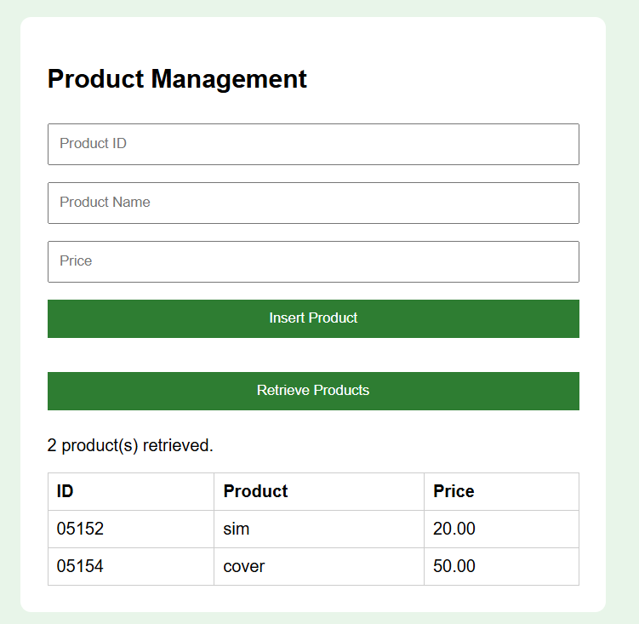
Using it in a servlet: a ProductServlet's doPost() reads the request parameters, validates them (for example Double.parseDouble inside a try-catch for NumberFormatException), calls dao.insertProduct(...) and forwards to a JSP that displays the results of displayAllProducts(). This keeps the layers separate: servlet (controller), DAO (data access), JSP (view).

Exception Handling in JDBC
    - SQLException is a checked exception, so every JDBC call must be in a try-catch or declared with throws. getMessage(), getSQLState() and getErrorCode() give details for debugging.
    - ClassNotFoundException occurs if the driver JAR is missing from the classpath.
    - Specific subclasses (e.g. SQLIntegrityConstraintViolationException, SQLTimeoutException) are caught before the general SQLException so that each case can be handled appropriately.
    - try-with-resources closes Connection, Statement and ResultSet automatically, even when an exception occurs, which prevents connection leaks. (The older style closes them in a finally block.)
    - For multi-step operations, use transactions: con.setAutoCommit(false), then commit() on success and rollback() in the catch block.
    - Show users a friendly message and log the technical details; never expose raw SQL errors or credentials.
try { con.setAutoCommit(false);
// ... several INSERT/UPDATE statements ... con.commit();
} catch (SQLException e) {
try { if (con != null) con.rollback(); } catch (SQLException ex) { ex.printStackTrace(); }
}
Best practices: always use PreparedStatement (prevents SQL injection), use a connection pool (e.g. HikariCP or a Tomcat DataSource) instead of opening a new connection per request, keep credentials outside source code, and keep database logic in DAO classes.

Code of Conduct:

I I.ANDROW EDISSON(192511136) certify that this submission is my original work and that I have adhered to the guidelines specified for this assessment.
I understand that any violation of academic integrity rules will result in disciplinary action.

Signature of the student:

RUBRICS FOR CALCULATION:

Criteria | Weightage (%) | Level 4 (Exemplary) | Level 3 (Proficient) | Level 2 (Developing) | Level 1 (Beginning)
Understanding of Scenario | 20% | Demonstrates clear and complete understanding of the scenario and context | Shows good understanding with minor gaps | Partial understanding; misses key aspects | Misinterprets or fails to understand the scenario
Identification of Key Issues | 20% | Accurately identifies all relevant issues and factors involved | Identifies most key issues with minor omissions | Identifies limited issues; some irrelevant points | Unable to identify key issues
Application of Concepts | 25% | Applies appropriate concepts effectively to address the scenario | Applies concepts with minor errors | Limited or partially correct application | Unable to apply relevant concepts
Decision Making | 20% | Makes well-reasoned, logical decisions with strong rationale | Makes reasonable decisions with some justification | Makes weak decisions with limited justification | No clear decisions made or rationale provided
Clarity of Response | 15% | Response is clear, structured, and logically presented | Generally clear with minor issues | Somewhat unclear or poorly structured | Disorganized and difficult to understand

